Handout 6.11: Place Setting Diagram and Sharing Agreement
Name: ____________________________________ Date: ______________ Period: ______
Print pages 1 to 4 for every student. Page 5 is the paper cut-out set for rooms with no flatware and for students who need to place pieces instead of writing.

Part 1. Draw it from memory first
Before your teacher shows you anything, draw a place setting. Plate, fork, knife, spoon, cup, napkin. You have 90 seconds. There is no penalty for being wrong.
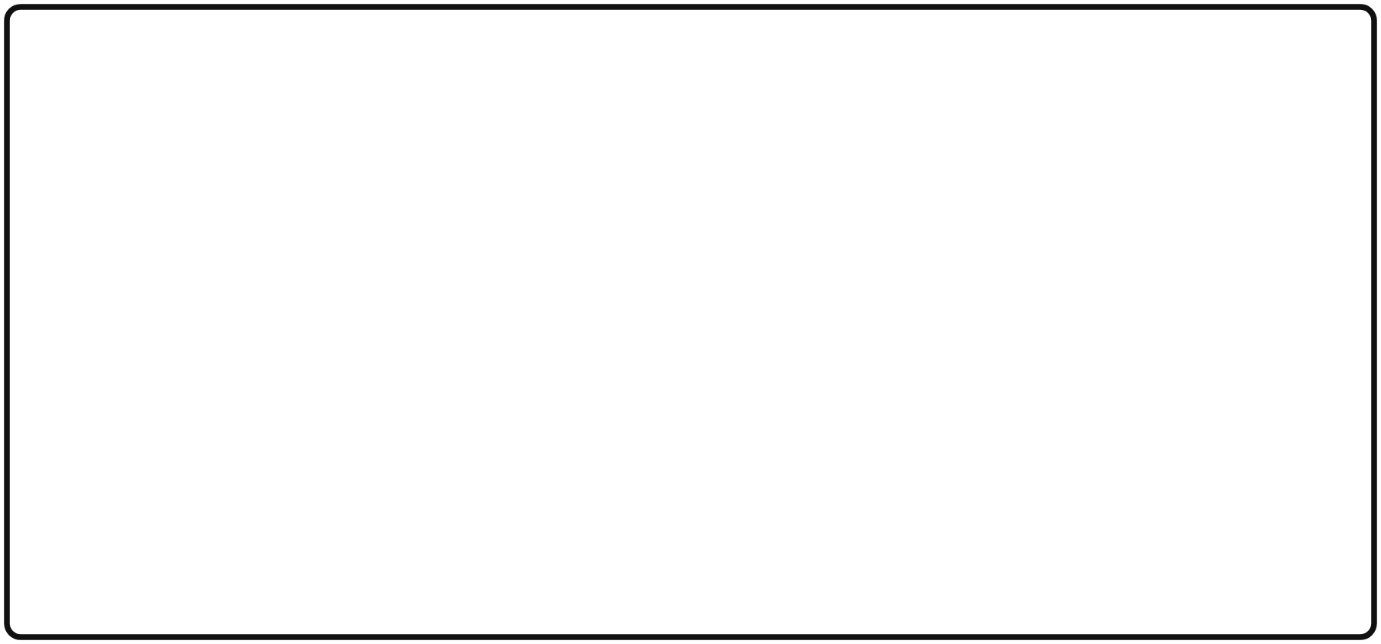
Draw a place setting from memory
After the lesson, come back and correct this drawing in a different color.

Part 2. The basic place setting
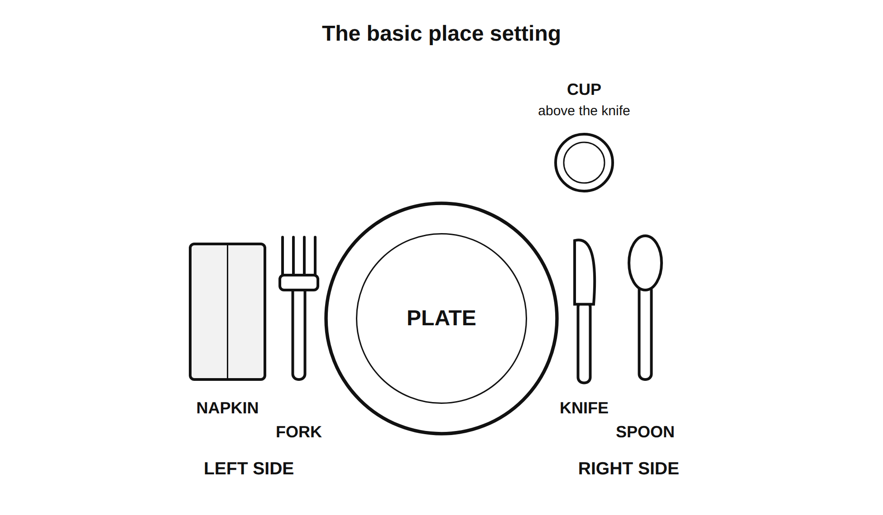
The basic place setting: napkin, fork, plate, knife, spoon, cup above the knife
Item | Where it goes | Why
Plate | Center, about an inch from the edge of the table | It is what everything else is arranged around
Fork | Left of the plate | Most people hold the fork in the left hand while cutting
Napkin | Left of the fork, or folded under it | Left side, out of the way of the knife hand
Knife | Right of the plate, blade turned in toward the plate | Safer for the person sitting there, and it is the courtesy
Spoon | Right of the knife | It is used after the knife in most meals
Cup or glass | Above the knife, on the right | Above the hand that reaches for it
Practice: set a basic place setting at your spot. Have a partner check it against this diagram.
Partner’s initials: ______
Why does the blade face in? _______________________________________________

Part 3. The formal place setting and the outside-in rule
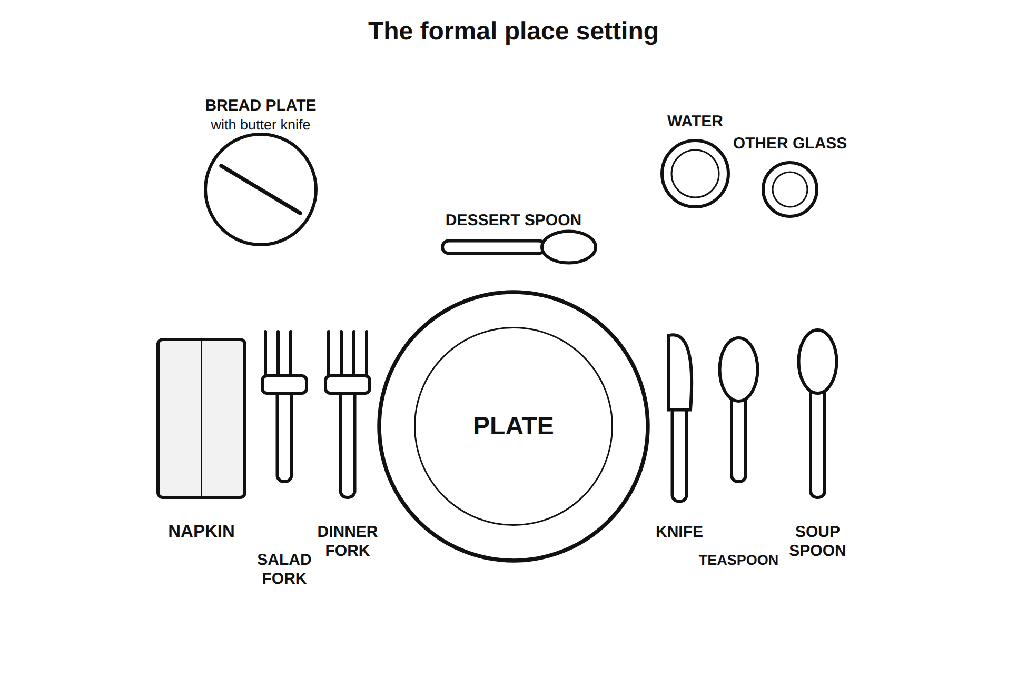
The formal place setting: bread plate, salad and dinner forks, dessert spoon, knife, teaspoon, soup spoon, water and a second glass
The outside-in rule: you use the utensils in the order the courses arrive. You work from the outside toward the plate. So the salad fork sits outside the dinner fork, and the soup spoon sits outside the teaspoon. If you do not know which fork to use, start at the outside and work in.
Course order | Utensil you reach for | Where it is
1. Soup | Soup spoon | Farthest right
2. Salad | Salad fork | Farthest left
3. Main dish | Dinner fork and knife | Inside, closest to the plate
4. Dessert | Dessert spoon or fork | Above the plate
Practice: set a formal place setting. Partner checks.
Partner’s initials: ______
A question to answer in one sentence: most families own three pieces of flatware (forks, knives, and spoons) per person, not six. Does that make the formal setting useless?
Answer: _____________________________________________________________________________

Part 4. Three other ways people serve and eat
Walk to the three stations. The bowl of water beside Station 3 is the right hand system, so fill in all four rows.
Station | What it is | One hosting practice it uses | One thing it has in common with a place setting
Shared platter
Chopsticks
Right hand
Bento or tiffin box
What do all four systems have in common? Every one of them has a rule about ______________________________________________________________________________.

Part 5. Hosting basics
Three practices that cross every system:
- ___________________________________________________________________________
- ___________________________________________________________________________
- ___________________________________________________________________________

Part 6. Our class food sharing agreement
Write three to five rules with your group. Each rule has to be a thing a person does, not a feeling. “Be respectful” is not a rule. “Serve the person next to you before you serve yourself” is a rule.

My group’s draft
# | Rule (something a person does)
1
2
3
4
5

The class version, after the vote
# | Our class rule
1
2
3
4
5

The hard case
Pick one rule from the class agreement. Describe a situation where it would be hard to follow. Then say what you would do.
The rule: ____________________________________________________________________
The situation: _______________________________________________________________
Line 3: _____________________________________________________________________________
What I would do: _____________________________________________________________
Line 5: _____________________________________________________________________________
This agreement is going on the wall, and it is the rule for serving day in the Feed the Class project.

Page 5: Paper cut-out set
Print, cut apart, and place on a blank sheet instead of using real flatware. One set per student.
PLATE (large circle) | FORK | KNIFE
SPOON | CUP | NAPKIN
SALAD FORK | TEASPOON | SOUP SPOON
DESSERT SPOON | BREAD PLATE (small circle) | WATER GLASS
Place them on this outline:
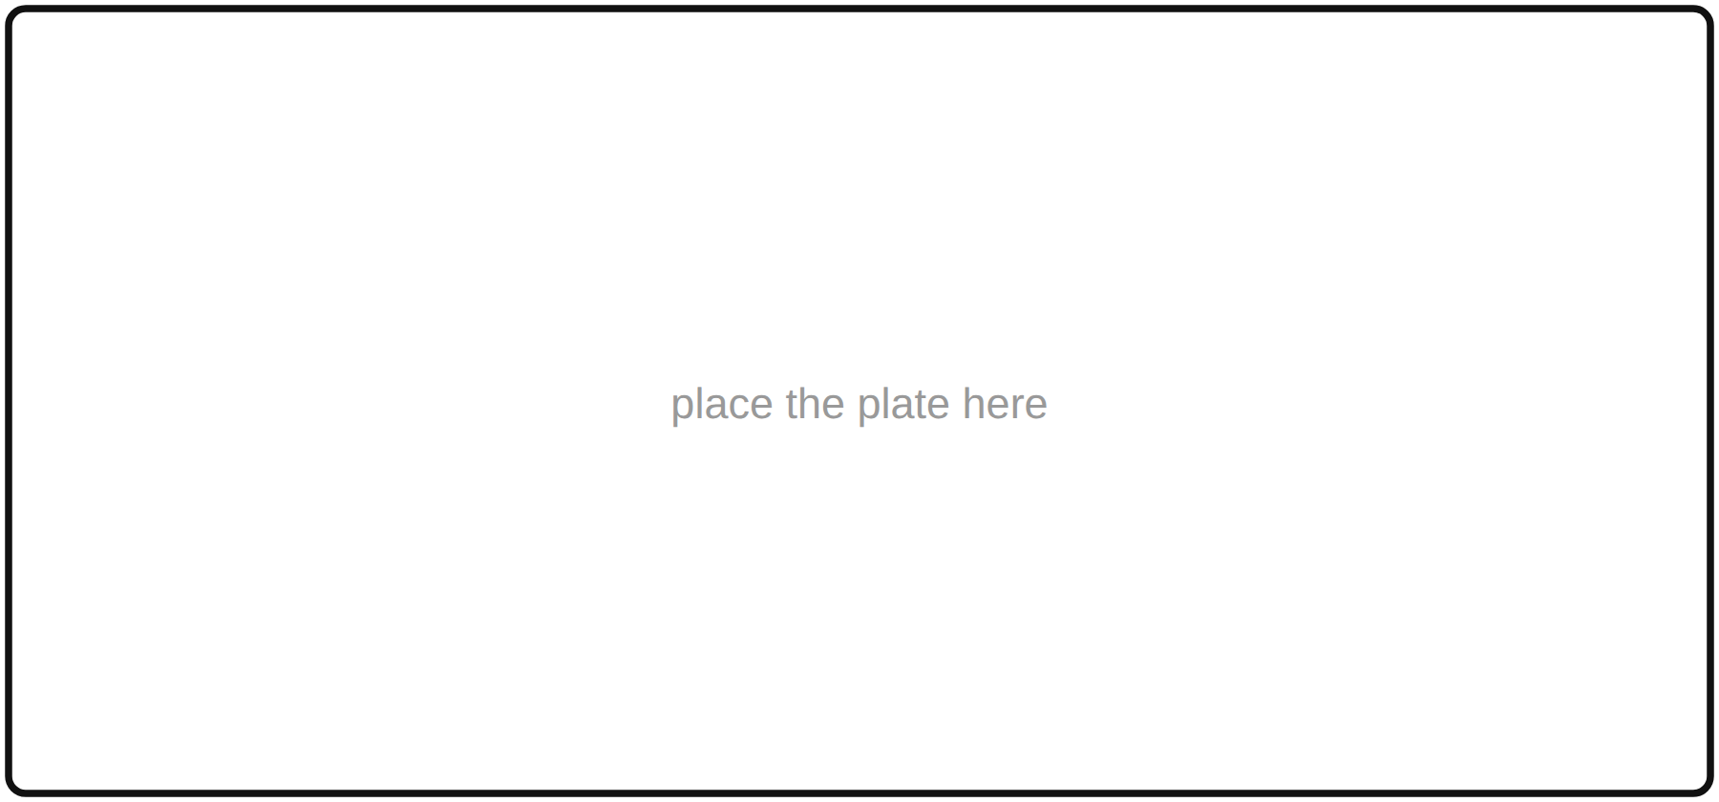
Place the cut-out pieces on this outline

Grade 8 stretch
- Set a formal place setting with this handout face down. Then check it and mark what you missed.
What I missed: _______________________________________________________________
- Add the glasses. A formal setting has a water glass and often a second glass above the knife. They are set in the order they are used, with the first one closest to the hand.
Draw them in on your formal setting diagram.
- The hard question: name one rule from the class agreement that would clash with a practice at one of the three stations. Say how a good host would handle both.
The rule: ____________________________________________________________________
The practice it conflicts with: ______________________________________________
How a host handles both: _____________________________________________________
Line 4: _____________________________________________________________________________

